**Denholm Dean Community Woodland Sponsor a Tree**

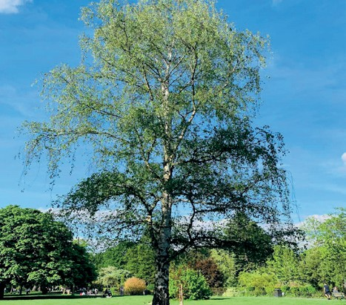

*Birch*

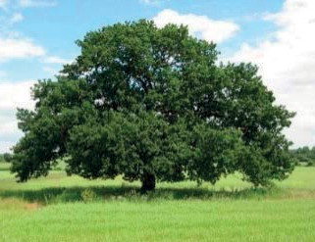

*Oak*

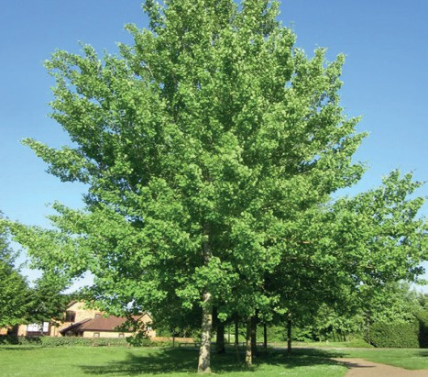

*Aspen*

The Denholm Dean Committee is currently preparing to replant the Lower Dean with 1400 mixed broadleaf trees now that all the Sitka Spruce have been felled.

The Sponsor an Oak appeal has been so successful that we are extending it to include Birch and Aspen. Birch is a beautiful slender tree with silver bark bringing light and life to new woodlands.

Aspen is known for its trembling leaves and its unique sound in the forest.

To help cover the cost of replanting those trees and others and to create a fund for future maintenance, you are invited to become a sponsor by donating £10 for one tree or more for additional trees.

If you are able to help in this way, please complete the sponsor form and send it to any of your friends or family you think would also help.

Your name and sponsorship number will be on the Community Woodland page of the Denholm Village website - unless you wish to be anonymous. A number on the stake beside the tree guard will identify your tree.

# Sponsorship Form

Name (s) …… …….. ………………………………………… Date ..…………………..…………………

# Please tick ✓

Tree species □ Birch □ Aspen □ Oak

Amount *□ 1 tree £10 □ 2 trees £20 □ .…..trees £..…..*

Donation paid: cash □ cheque □ direct to bank (details below) □

□ Sponsor list or □ Anonymous

Gift Aid – are you a UK tax pabyer? Yes □ No □

Bank details: Denholm Feuars

Sort code: 80-16-22 A/c No: 00165659

**Please return this form with your donation to Denholm Post Office or email it to** [**sponsoranoak@gmail.com**](mailto:sponsoranoak@gmail.com)