**Denholm Dean Community Woodland**

**Sponsor an Oak Tree**

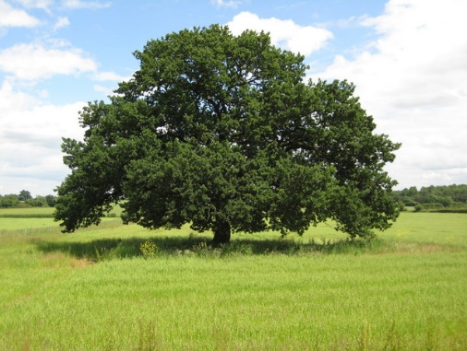

The Denholm Dean Committee is currently preparing to replant the Lower Dean with 1400 mixed broadleaf trees now that all the Sitka Spruce have been felled.

Oak has been chosen for the appeal because of its strength and longevity, so it can be enjoyed by the Denholm Community for generations to come.

To help cover the cost of replanting and to create a fund for future maintenance, you are invited to become a sponsor by donating £10 for one tree or more for additional trees.

If you are able to help in this way, please complete the sponsor form and send it to any of your friends or family you think would also help.

Your name and sponsorship number will be on the Lower Dean page of the Denholm Village website - unless you wish to be anonymous. A number on the tree guard will identify your tree.

**DENHOLM DEAN COMMUNITY WOODLAND**

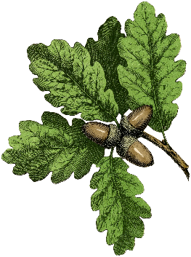**Sponsorship Form**

Name …………………………………………

Date ..…………………..…………………

**Please tick ✓**

Sponsorship amount:

□ 1 tree £10 □ 2 trees £20 □ .…..trees £..…..

Donation paid: cash □ cheque □ direct to bank (details below) □

□ Sponsor list or □ Anonymous

Gift Aid – are you a UK tax payer? Yes □ No □

Bank details: Denholm Feuars’ & Householders’ Council Sort code: 80-16-22 A/c No: 00165659

**Please return this form with your donation either to Denholm Post Office or Denholm Primary School or email it to** [**sponsoranoak@gmail.com**](mailto:sponsoranoak@gmail.com)